**Smart Irrigation**

A dissertation submitted to

**UKA TARDASIA UNIVERSITY**

In Partial Fulfillment of the Requirements for the Degree of

**Master of Science**

In

**Information Technology**

For

**5 Years Integrated M.Sc. (IT)**

By

**Vishva U Harsora**

201806100110059

**Vishwa M Chaturvedi**

201806100110127

Guided by

**MRS. Abha Damani**

**Assistant Professor**



**Babu Madhav Institute of Information Technology**

**Uka Tarsadia University**

**Bardoli – 394350**

**May 2022**

**CANDIDATE’S DECLARATION**

We declare that the dissertation for M. Sc.IT. entitled **“Smart Irrigation”** is our own work conducted under the guidance of **MRS. Abha Damani**

We further declare that to the best of our knowledge, the dissertation does not infringe upon anyone’s copyright nor violate any proprietary rights and that any ideas, techniques, quotations, or any other material from the work of other people included in our dissertation, published or otherwise, are fully acknowledged in accordance with the standard referencing practices.

**Place:**

**Date:**

**Enrollment No:** 201806100110059 & 201806100110127

**Name:** Ms. Vishvaharsora & Ms. VishwaChaturvedi

**Sign:**

**CERTIFICATE**

This is to certify that research work embodied in this dissertation entitled “**Smart Irrigation”** was carried out by Ms. Vishvaharsora & Ms. VishwaChaturvedi (Enrolment no: 201806100110059 & 201806100110127) at **Babu Madhav Institute of Information Technology** for the partial fulfillment of **Master of Science in Information Technology** degree to be awarded by **UKA TARSADIA UNIVERSITY**. This research work has been carried out under my supervision and is to my satisfaction.

**Date:**

**Place:**

|  |  |
| --- | --- |
| **MRS. Abha Damani**  **Guide** | **Dr. Jitendra Nasriwala**  **I/C Director** |

**External Examiner**

|  |
| --- |
|  |
|  |

**Seal of Institute**



**Babu Madhav Institute of Information Technology,**

**Uka Tarsadia University,**

**Bardoli – 394350**

**Acknowledgements**

I would like to express my sincere thanks to Mrs Abha Damani for her valuable guidance and support in completing my project.

I would also like to express my gratitude towards our Head Of Department Mr Jitendra Nasriwala for giving me this great opportunity to do a project on SMART IRRIGATION. Without their support and suggestions, this project would not have been completed.

At last, I would like to extend my heartfelt thanks to DR. SAPAN NAIK for his further guidance and help.

**Ms. Vishava Hasora**

**& Ms. Vishwa Chaturvedi**

***Abstract***

*Automation of farm activities can transform agricultural domain from being manual and static to intelligent and dynamic leading to higher production with lesser human supervision. This paper proposes an automated irrigation system which monitors and maintains the desired soil moisture content and sense soil nutrition via smart irrigation and nutrients sensing system. Arduino platform is used to implement the control unit. The setup uses soil moisture sensors which measure the exact moisture level in soil. This value enables the system to use appropriate quantity of water which avoids over/under irrigation. IOT is used to keep the farmers updated about the status of soil and irrigation . Information from the sensors is regularly updated on a webpage using GSM-GPRS SIM900A modem through which a farmer can check whether the water pumps are ON/OFF at any given time. Also, the sensor readings are transmitted to a Thing speak channel to generate graphs for analysis.*

*Key words-*

Table of Contents

1 Introduction 1

1.1 Problem Statements: 2

2 Related Work 2

3 Proposed Work 6

3.1.2 Pin Configuration 7

3.1.3 Circuit Diagram 8

3.1.4 Result 10

4 Conclusion 11

5 References 11

List of Figure

Figure 1 Circuit Diagram 8

Figure 2 Prototype 9

Figure 3 Result obtained 10

List of Tables

Table 1Connections of Soil Moisture sensor with ESP8266 7

Table 2 Connections of DHT11 with ESP8266 7

Table 3Connections of Relay with ESP8266 8

1. **Introduction**

Agriculture is the unquestionably the largest livelihood provider in India. With rising population, there is a need for increased agricultural production. In order to support greater production in farms, the requirement of the amount of fresh water used in irrigation also rises. Currently, agriculture accounts 83% of the total water consumption in India. Unplanned use of water inadvertently results in wastage of water. This suggests that there is an urgent need to develop systems that prevent water wastage without imposing pressure on farmers. Over the past 15 years, farmers started using computers and software systems to organize their financial data and keep track of their transactions with third parties and also monitor their crops more effectively. In the Internet era, where information plays a key role in people's lives, agriculture is rapidly becoming a very data intensive industry where farmers need to collect and evaluate a huge amount of information from a diverse number of devices (eg., sensors, faming machinery etc.) in order to become more efficient in production and communicating appropriate information. With the advent of open source Arduino boards along with cheap moisture sensors, it is viable to create devices that can monitor the soil moisture content and accordingly irrigating the fields or the landscape as and when needed. The proposed system makes use of arduino platform and IOT which enable farmers to remotely monitor the status of water pump ,soil moisture sensor and nutrients senrors installed on the farm by knowing the farm activities.

* 1. Problem Statements:

**Aims and Objectives:**

* In Agriculture Sector, Farmers needs to Manage ample amount of tasks and the most important one is the irrigation in the filed(Timely, Accurately, Needy)
* In Order to overcome this they need more of human resources, Energy, Time & for all this money of course
* So, to overcome this problem and to automate the process a smart irrigation system can be effective and appropriate.
* This will help farmers in numerous ways to go on with farming & irrigation plants in a smart way.

1. **Related Work**

* Nor Adni and Zuraida [1]

**1. Proposed System**: Considering this documentation they initially looked at the idea of developing a system that processes the data obtained from the soil sensor which will then automatically water plants accordingly and analyze the real time condition of soil. The main focus of the study is for crop’s welfare and production. They convey in the paper that the system is not so advanced and is still ineffective when it comes to the measurement of moisture of soil.

**2. Experiments and Results:** The following paper shows result and discussion on the basis of comparison of normal irrigation and smart irrigation, direct sunlight and 20% sunlight, low ph level and high ph level and the weather condition that is windy and not windy. And according to the paper smart irrigation gives the best desired result than the normal one.

**3.Conclusion and future enhancement**: The paper conveys that all the 3 desired objective were accomplished that is: 1.first to make iot based smart irrigation system 2. second is developing automated system with Arduino mega and 3. third is to analyze the real time condition of soil and plants, And in future it can be improved further by making use of solar and the system could go eco-friendly.

* Prabha and sarla [2]

**1. Proposed System:** In this documentation, they focus on the way of farming which eliminates the idea of more water and space consumption and aim to build an automated irrigation system that incorporates the data from all sensors and transfer to IOT server through network HYDROPONIC FARMING an approach of smart irrigation.

**2.method and technique used:** They talk about the NUTRIENT FILM TECHNIQUE which is most prevalent technique and for that indoor plantation, environmental temperature Ph value, humidity, electrical conductivity and water temperature are to be monitored and controlled. The system is been developed in such a way that the data can be read on the web base application. Further they talk about machine learning techniques used to predict plant growth. Their main motive intended in the paper is to check the moisture level in soil. The proposed system in the paper comprises of structured hardware, control section, data analysis and a frost algorithm to bring the system in implementation. **3.conclusion and future enhancement:** Hence this hydroponic system emerged to be fruitful and the data collected and analyzed accelerated in efficient plant growth. in future image processing technique can be used to predict the diseas of plants - **Hydroponic:** the process of growing plants in sand, gravels or liquid ( places other than land)

* Md. Mominur Rahman, Abu Shufian and Riadul Islam [3]

**1. Proposed system:** According to this paper the main purpose of the developed system is to make efficient utilization of solar power in irrigation and notify the owner about the need of supply of water through SMS.

**2. working of proposed system:** The proposed system works according to the soil moisture and keep updating owner about the condition of the crops and soil through GSM technology. The motor is turned ON and OFF automatically on the condition and demand of soil.

**3. comparison and result:** Furthermore, the paper shows the comparison between the proposed irrigation system and the traditional existing system which conveys that the proposed system is far better as it uses solar energy, it has ability to operate automatically and it will make efficient use of water and there won’t be any wastage also that it will a low cost system, low power consumption and low maintenance needed.

* Ravi Kishore Kodali [4]

1. **proposed system:** This documentation intended the idea of designing a simple WATER PUMP CONTROLLER by using soil moisture sensor and Esp8266 NodeMCU-12E, depending on the soil moisture level, it will control the supply of water and display the sensor data and pump status on web page or mobile.
2. **Objective:** The major objective of proposing this system is to collect the data from the sensor and send this data to the user so whenever they want to check the required soil moisture and water pump status they can.
3. **Advantages:** The advantage of this system is that farmer can turn on and off the water pump by internet connectivity and automate the process.
4. **system design implementation:** The system is designed in such a way that the first section consists of sensor and relay and the second section consist of MQTT –thinger.io and display obtained results.
5. **Conclusion:** Also that ESP8266 Node-MCU 12E is low cost, low power consumption, small microcontroller which makes proposed system appropriate for given application And the high precision soil moisture sensor provides analog reading, so we correctly measure soil moisture value. And finally they display all the reading in mobile app and web page.

* Arijit Ghosh [5]

1. **proposed solution:** This paper focused on an automated irrigation system which regularly supervise RH of soil and controls supply of water but here in practice, the pump on which control action is to be taken is at a distance from the irrigation land. The current work aims to develop a wireless microcontroller based low cost RH monitoring system that can track RH at different locations of the field in real time. Moreover, as thought of it allows water to be sprinkled on the field if soil moisture falls below a threshold limit depending upon the nature of crop grown in the soil.
2. **Design and implementation:** Here the system design flow chart states that 4 out of 14 channels are used to drive different devise, first for scanning the system, second for displaying the value of supply voltage, third for measurement and wireless control of RH and fourth for measuring soil temperature acquis ion of data.
3. **conclusion:** Hence automation helps in fruitful utilization of water. They say system can be further modified by incorporate intelligent control of sprinkle flow, message can be conveyed from environment to the controller ‘CAN’ can be implemented to setup communication between distributed nodes for irrigation system. These are the possibilities that can be implemented in future according to the paper.

* K. Lova Raju and Vijayaraghavan Veeraman [6]

1. **Proposed system:** In this paper design of system is for to monitor the state of soil with sensor connected to node MCU by analyzing and pretending the data with the help of the WEKA tool by using raspberry pi3 as a broker for MQTT protocol. Agriculture is the main source of food and India is also known as farming staple in the world but some farmer doesn’t known about the usage of specific pesticides for specific crop. In this paper it is mention that how much water is required for each crop and also the hardest part is that labor is unaware of the amount of water to be needed in specific season. Here with help of wireless sensor networks and raspberry pi 3 are treated as one of the most essential peripherals in IOT agriculture. To increase performance use lightweight protocol message queuing telemetry transport(MQTT).
2. **Best result and conclusion:** In this paper DTH-11 and moisture sensor are used. DTH-11 sensor gives the value of temperature and humidity with digital data. The moisture sensor connected with the node MCU is analyzed at the cloud or with WEKA tool locally which is the best part of this paper.
3. Proposed Work

In this study we have focused on our research on overall development of the smart irrigation technology for the farmers I.e., with this proposed architecture one can sense detect the **soil moisture** as well as **soil nutrient level.**

So, this system would efficiently help to monitor the health of the soil as well as the crops they will sow within just a click on the phone in Real-time. This system would help to increase the productivity of the farming product drastically and would help the farmer detect the nutrient level and soil conditions. India is agriculture dominant country. Agriculture lands generally located in remote areas of the country. Thus, approaching field again and again is very difficult. This would help in real time access of the health and condition status of the crops and soil.

**3.1). Soil moisture and component**

**3.1.1 The system includes the following hardware for efficient use.**

1.ESP8266:

The ESP8266 WiFi Module is a self contained SOC with integrated TCP/IP protocol stack that can give any microcontroller access to your WiFi network. The ESP8266 is capable of either hosting an application or offloading all Wi-Fi networking functions from another application processor

2.Soil Moisture Sensor:

 used to read the analog signal produced by a soil moisture sensor probe. The data is then used to determine the color of a blinking RGB LED. If the sensor detects low moisture the LED is red, medium is green and high moisture is blue

3.Dht11:  
 is a basic, ultra low-cost digital temperature and humidity sensor. It uses a capacitive humidity sensor and a thermistor to measure the surrounding air, and spits out a digital signal on the data pin.

4. Relay Module:   
A power relay module is an electrical switch that is operated by an electromagnet. The electromagnet is activated by a separate low-power signal from a micro controller. When activated, the electromagnet pulls to either open or close an electrical circuit.

* + 1. Pin Configuration

The device is equipped with ESP8266, Soil Moisture sensor, DHT11 sensor, Relay Module, Motor , power supply

First, you need to place the ESP8266 Next, attach the Soil Moisture sensor and DhT11 to ESP8266.relay modul to ESP8266 and power supply to motor and relay modul

Table 1Connections of Soil Moisture sensor with ESP8266

|  |  |
| --- | --- |
| **ESP8266** | Soil Moisture sensor |
| 3v3 | power |
| GND | GND |
| A0 | OUT |

Table 2 Connections of DHT11 with ESP8266

|  |  |
| --- | --- |
| **ESP8266** | **DHT11** |
| 3v3 | (+) |
| GND | (-) |
| OUT | D4 |

Table 3Connections of Relay with ESP8266

|  |  |
| --- | --- |
| **ESP8266** | **Relay modul** |
| Vin | VCC |
| GND | GND |
| D4 | pin |

* For relay connection negative(Motor) to negative(battery) and positive in relay module.
* 5v power supply to the circuit to use 5V Battery

3.1.3 Circuit Diagram

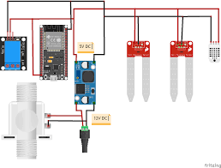

Figure 1 Circuit Diagram

* **How It Work:**

Continuously monitors the parameters temperature, humidity, PH and moisture of soil. An algorithm was used with threshold values of soil moisture to be maintained continuously. System starts or stops irrigation based on moisture content of the soil. Water level sensor is connected to main irrigation canals, and flow sensor is connected to water pump. These sensors are connected to wireless gateway which sends data periodically to web server. Database connected to web server monitors irrigation water level at all main. The web based analyzes the data stored in database and compares with specified values. Then it sends to farmers and engineers to make aware of water requirement

* **Prototype:**

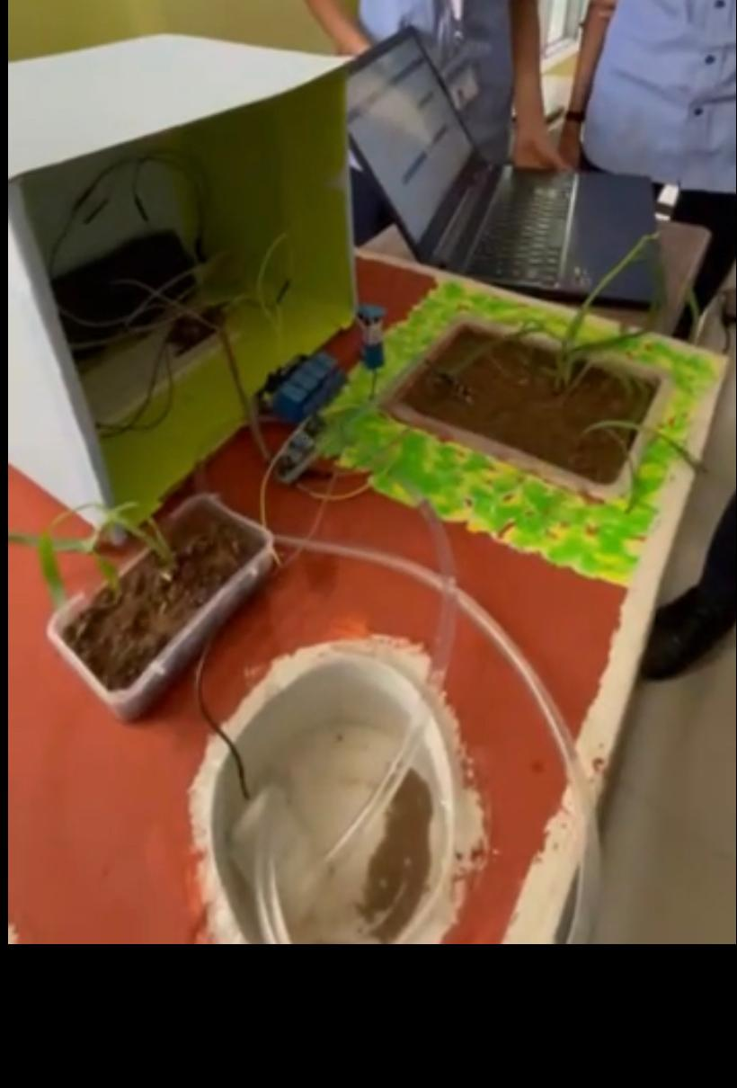

Figure 2 Prototype

* + 1. Result

Link: <https://thingspeak.com/channels/1702528>

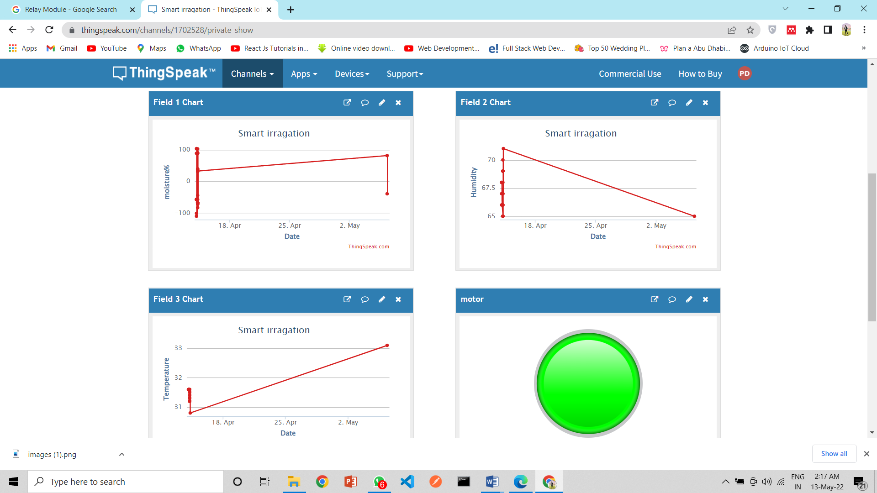

Figure 3 Result obtained

**3.2) soil nutrient and Analysis**

As the water is important for crops the nutrients are important for soil too ,so we also need to sense the amount of nutrients in the soil

Soil fertility is an important factor to measure the quality of the soil as it indicates the extent to which it can support plant life. The fertility of soil is measured by the amount of macro and micronutrients, water, pH etc. Soil nutrients are depleted after every harvest and hence must be replenished. To maintain nutrient levels in the soil in case of deficiency, fertilizers are added to soil. Most of the farmers choose to approximate the amount of fertilizers and add them manually.

The proposed research aims at restoring the levels of Nitrogen, phosphorous, potassium in the soil by the measuring the amount of nutrients present. The presence of nutrients is determined by chemical processes and quantified using sensors.

Based on algorithm we can identify the need of nutrients in the soil and user can see the need of nutrition on webpage and accordingly can spray the fertilizers

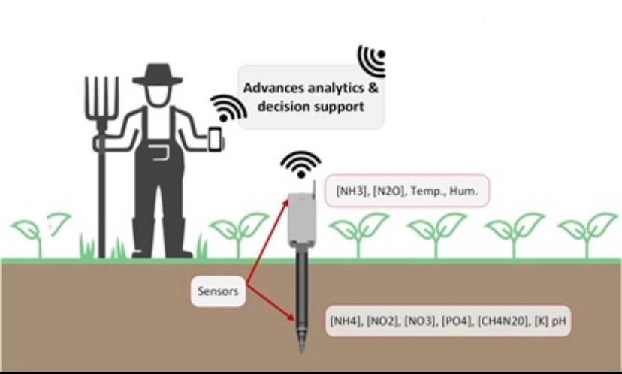

1. Conclusion

In the end of this paper we can clearly conclude that there is a need to develop a complete smart irrigation system with nutrients sensing and provide extra supplement quantity analyzed by the algorithm which are mandatory. Crop’s health is equally important as human health and the research is much needed in the domain of non-invasive sensor technology and power consumption of smart irrigation and nutrition system.

Benefits of using this system in agricultural sector will be able to provide boom in agricultural production. In addition it will make less wastage of water, fertilizers as well as the agricultural products.

1. **References**

HEC